Citrus Quinoa Salad
From Chelseasmessyapron.com
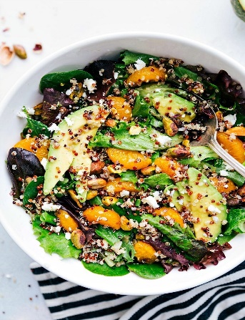
Ingredients
½ cup uncooked quinoa (tri-color or regular - both work)
5 cups fresh spring mix (baby lettuces and baby greens)
3-4 fresh clementines
1/3 cup shelled and coarsely chopped nuts of your choice
1/3 cup crumbled goat or feta cheese
1 large ripe avocado diced
1 tsp fresh lemon juice (optional)

Instructions
- Combine Quinoa and water with salt if desired in a small pot. Follow package directions to cook the quinoa. Cook until all of the liquid is absorbed and quinoa has “popped,” about 15-25 minutes. Remove from heat and let stand, covered for 5-10 minutes to steam. Fluff with fork, transfer to a bowl in refrigerator to chill. NOTE Quinoa can be prepared 3-4 days in advance.
- Salad assembly: In a large bowl, add the spring mix and the cooked, completely cold quinoa. Gently toss to combine. Add in the oranges, nuts, goat cheese and avocado.

Chelsea’s dressing for this salad:
¼ tsp minced garlic
½ tsp Dijon mustard
2 tbsp apple cider vinegar
1 tbsp fresh squeezed lemon juice
1 tbsp fresh squeezed orange juice
2 ½ tbsp extra virgin olive oil
1 ½ tbsp honey
Fresh cracked pepper and sea salt to taste

Dressing prep
Add all ingredients to a mason jar Add salt and pepper to taste, Seal jar and shake until ingredients are combined. Refrigerate until ready for use.
Note: Use this dressing or any similar dressing that you prefer.

Nutrition
Calories 244 kcal, Carbohydrates: 20g, Protein: 8g, Saturated fat: 4g, Cholesterol: 12mg,
Sodium: 220 mg, Potassium: 761mg, Fiber: 7g, Sugar: 9g, Calcium: 170mg, Iron: 3mg,
Vitamin C: 36mg, Vitamin A 15058iu

